MULTIMEDIA ASSIGNMENT

**2010**

HIRAKJYOTI BANERJEE

M.SC. 3RD SEMESTER

11/1/2010

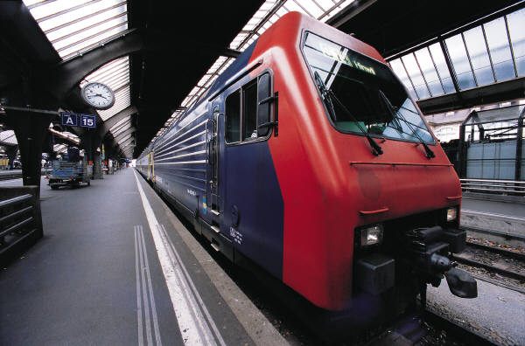

**ASSIGNMENT 1:**

**Problem:**

Write a C Program to draw some basic shapes such as Lines, Rectangle, Ellipse, Sector, and Polygon.

**Code:**

**ASSIGNMENT 2:**

**Problem:**

Write a program with colors, pixels, bars, and cleardevice using random number generation. We have a function random (no), it returns a random number between 0 and no. The effect is by drawing random radius, random color circles with same center and random pixels. khbit() function (defined in conio.h) returns a nonzero value when a key is pressed in the keyboard. So, the loop will continue until a key is pressed.

**Code:**

**ASSIGNMENT 3:**

**Problem:**

Given a finite number of cities (choose cities from 1 to a finite number) along with the distance of travel (distance between two cities randomly selected) between each pair of them. The aim is to find the cheapest distance of visiting all cities and returning to the start point.

**Code:**

**ASSIGNMENT 4:**

**Problem:**

Read and display an image. A *region of interest* (ROI) is a portion of an image to filter or perform some other operation on. You can define an ROI by creating a *binary mask*, which is a binary image that is the same size as the image you want to process with pixels that define the ROI set to 1 and all other pixels set to 0.

Create a Binary Mask.

You can use the createMask method of the imroi base class to create a binary mask for any type of ROI object – impoint, imline, imrect, imelipse, impoly, or imfreehand. The createMask method returns a binary image the same size as the input image, containing 1s inside the ROI and 0s everywhere else.

For example, suppose you want to filter the grayscale image I, filtering only those pixels whose values are greater than 0.5. You can create the appropriate mask with this command: BW = (I > 0.5).

**Code:**

**ASSIGNMENT 5:**

**Problem:**

The various mouse functions can be accessed by setting up the AX register with different values (service number) and issuing interrupt number 51. The functions are listed below:

1. Reset mouse and get status
2. Hide mouse pointer
3. Show mouse pointer

**Code:**